Experiment No: 3 Exporatory Data Analysis( Data cleaning and data Transformation)

Aim:
To import and export different types of files using python.

Algorithm:
- Start the program.
- Import the required libraries (pandas, numpy).
- Load the dataset into a DataFrame.
- Check the dataset structure using info().
- Identify missing values using isnull().sum().
- Handle missing values by removing or replacing them.
- Check for duplicate records using duplicated().
- Remove duplicate records using drop_duplicates().
- Identify outliers using statistical methods or box plots.
- Handle outliers by removing or capping extreme values.
- Verify that the cleaned dataset has no unwanted missing values or duplicates.
- Save the cleaned dataset (optional).
- Stop the program.

Program:
1.
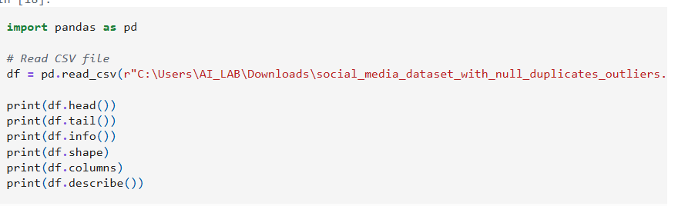
Output:

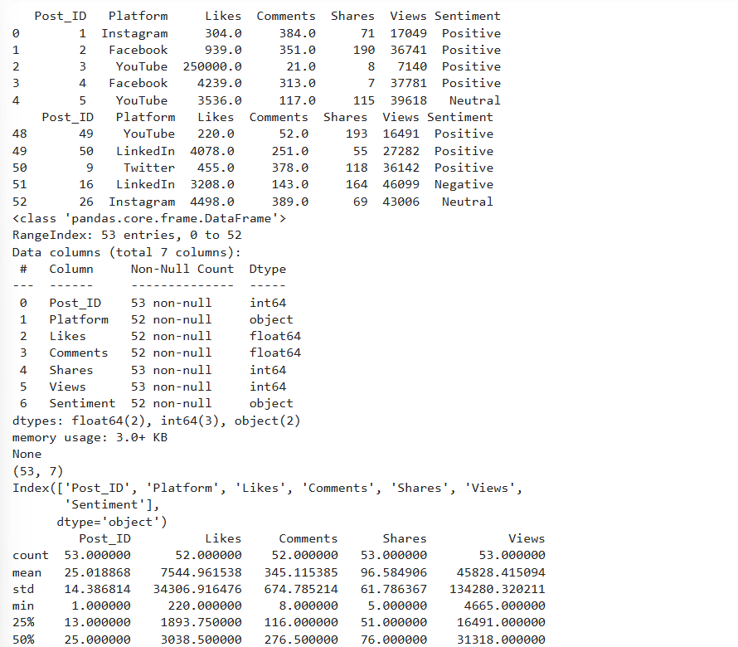

2.Is null:Output:

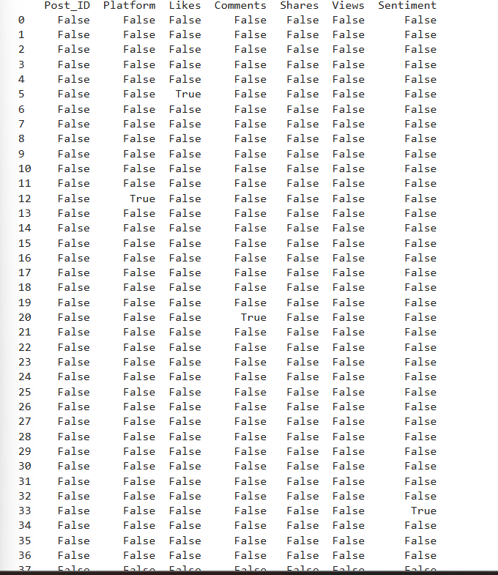

3.sum:
Output:
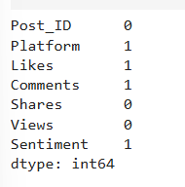

4 fillna:
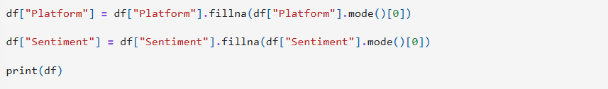
Output:
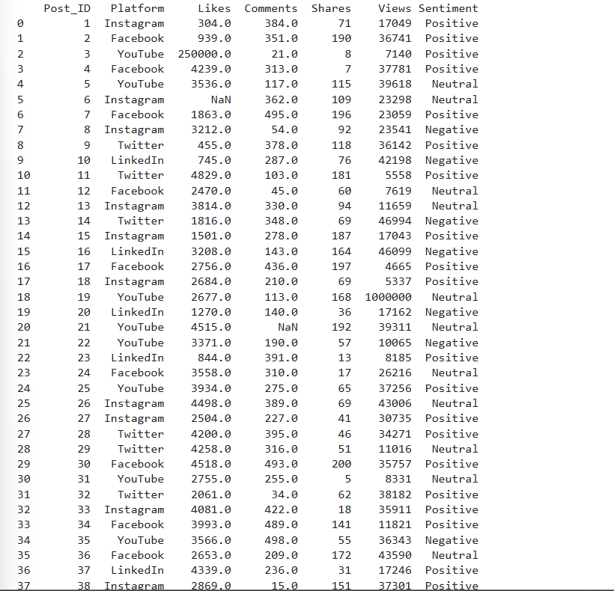

5 duplicate:
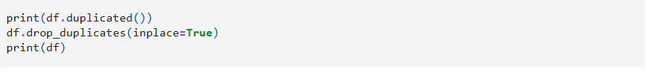
Output:
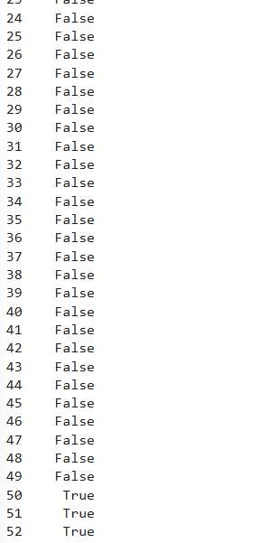
6 Outliers:
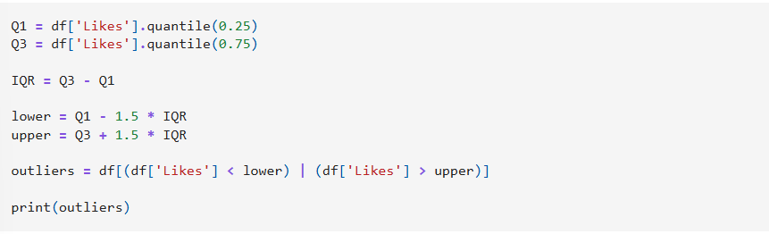

Output:

7 Transform:
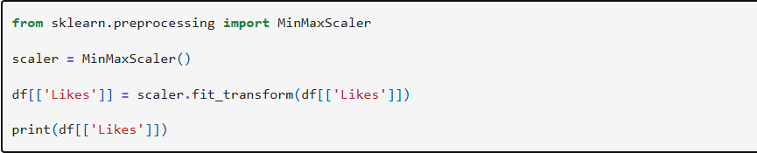
Output:
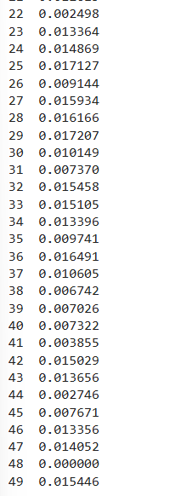
8 Encoder:
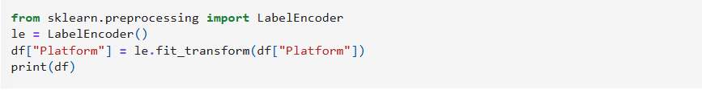

Output:
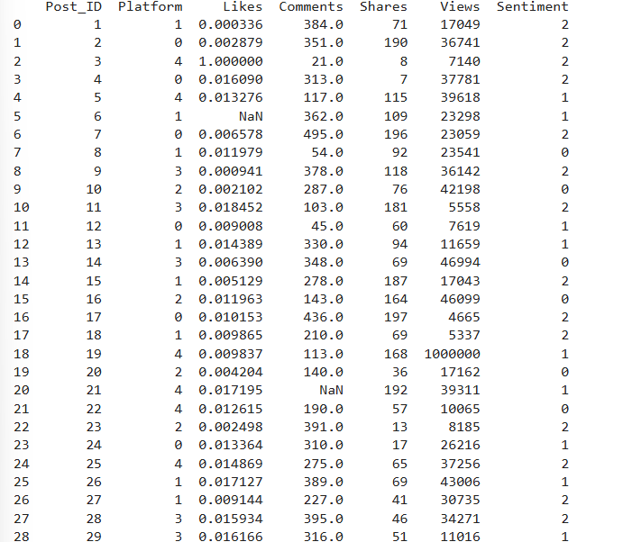

9.dummies:
Output:
